Enterprise Network Tender and Design Specification
Two-floor office | 100 Windows laptop users | Windows Server authentication | Synology NAS storage
Core outcome  Secure, scalable office network with managed wired and wireless access | Architecture basis  UniFi edge and switching, Windows Server identity, Synology storage | Design intent  Business-grade resilience, operational clarity, and room for growth

1. Executive summary
This document sets out a full small-business network design and tender specification for an organisation distributed across two office floors with 50 users per floor. The design assumes every member of staff uses a Windows laptop, identity and policy are delivered by Windows Server, and file storage and backup services are provided by a Synology NAS platform.
The design is intentionally structured around clear operational priorities: predictable user experience, secure access control, uncomplicated support, sensible resilience, and straightforward future expansion. In practice, that means using segmented VLANs instead of a flat network, managed PoE switching instead of unmanaged edge switches, standards-based enterprise wireless rather than consumer Wi-Fi, and centralised authentication rather than local-only device accounts.
The result is a network that is easier to support, safer to audit, and less likely to suffer from avoidable failures. It also creates a clean foundation for later growth into cloud-managed endpoints, hybrid identity, stronger endpoint compliance, or a second office location.

2. Architecture overview
The office is designed around a simple and defensible three-layer logic: an internet edge, a central switching and routing layer, and an access layer on each floor. This layout is used because it matches the support needs of a 100-user business without introducing unnecessary complexity. Staff traffic enters the network through either wired desk ports or business Wi-Fi, traverses a managed switching fabric, and is controlled by a gateway and firewall policy before reaching internal services or the internet.
A central firewall or gateway sits at the edge because it provides one place to enforce internet access policy, remote-access VPN, logging, and threat controls. A 10Gb-capable core and aggregation layer is used because inter-floor uplinks, server traffic, and storage traffic should never contend with access-layer bottlenecks. Floor-level PoE access switching is used because access points, phones, and some shared devices are better powered and managed centrally than through scattered power injectors or local adapters.
The topology below is shown in a Visio-like style to help both technical and non-technical stakeholders understand how the environment is arranged. It separates edge security, user access, server services, and storage in a way that mirrors the operating model of the business.
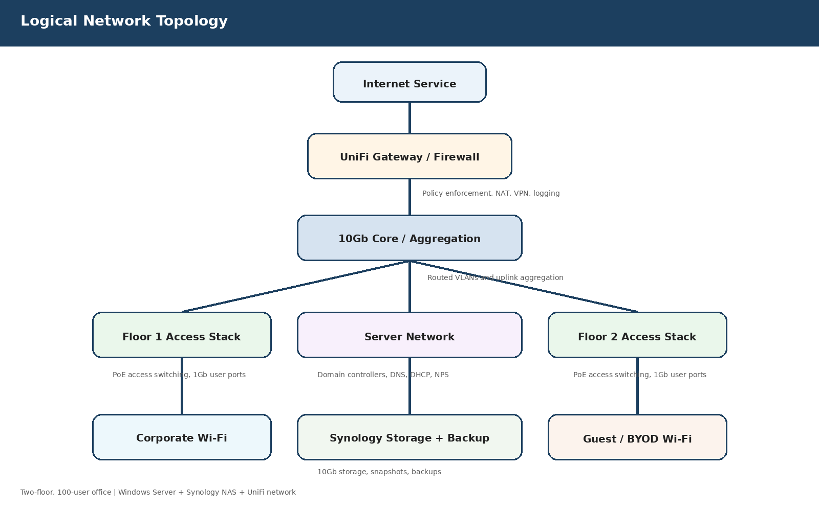
Figure 1. Logical network topology and service domains.

3. Detailed wired network design
Structured cabling should be delivered as Cat6 at minimum, with Cat6a preferred where budget and pathway space allow. The reason for this recommendation is not only headline bandwidth but operational longevity: replacing horizontal cabling is disruptive and expensive, while the price difference at installation stage is usually far less painful than re-cabling later.
Each floor should be served by managed PoE+ access switches sized with spare capacity. For a floor with 50 users, a practical design is either two 48-port managed PoE switches or one 48-port plus one 24-port switch, depending on how many desks are actually wired and how many devices are expected in meeting rooms, printers, and access points. The spare ports matter because office networks rarely remain static; new printers, APs, room devices, and temporary desks appear over time.
Uplinks from the floor stacks to the core should run at 10Gb over fibre. This is important because uplinks aggregate many simultaneous users. A single 1Gb uplink might function under light load, but it leaves less margin for large file operations, backups, Teams calls, Windows updates, and bursty cloud traffic. A 10Gb backbone keeps the user experience stable and avoids false performance complaints that are actually switching bottlenecks.
Link aggregation should be used where supported for resilience and throughput. This does not replace good design or backups, but it does reduce the chance that a single failed uplink or transceiver takes out an entire floor.

4. Wireless network design and reasons for the chosen approach
Wireless access should be based on centrally managed Wi‑Fi 6 access points rather than domestic or small-office Wi‑Fi hardware. The reason is not branding; it is control. Business Wi‑Fi needs consistent channel planning, roaming behaviour, per-SSID policy, remote troubleshooting, firmware control, and reporting. Consumer equipment usually becomes difficult to govern once multiple APs and multiple floors are involved.
For an office of this size, an indicative starting point is four access points per floor, subject to a post-installation survey. This provides enough density for user laptops, mobile devices, and meeting areas without immediately overloading channels. More importantly, it creates overlapping coverage so that users moving between desks, meeting rooms, and collaboration spaces do not experience dead zones or sticky roaming.
The planning target should be to achieve at least around -65 dBm in normal working areas. That target is widely used because it balances usability for modern productivity applications with controllable AP density. Designing only for basic connectivity can produce a network that technically works while still feeling poor under Teams calls, screen sharing, and cloud applications.
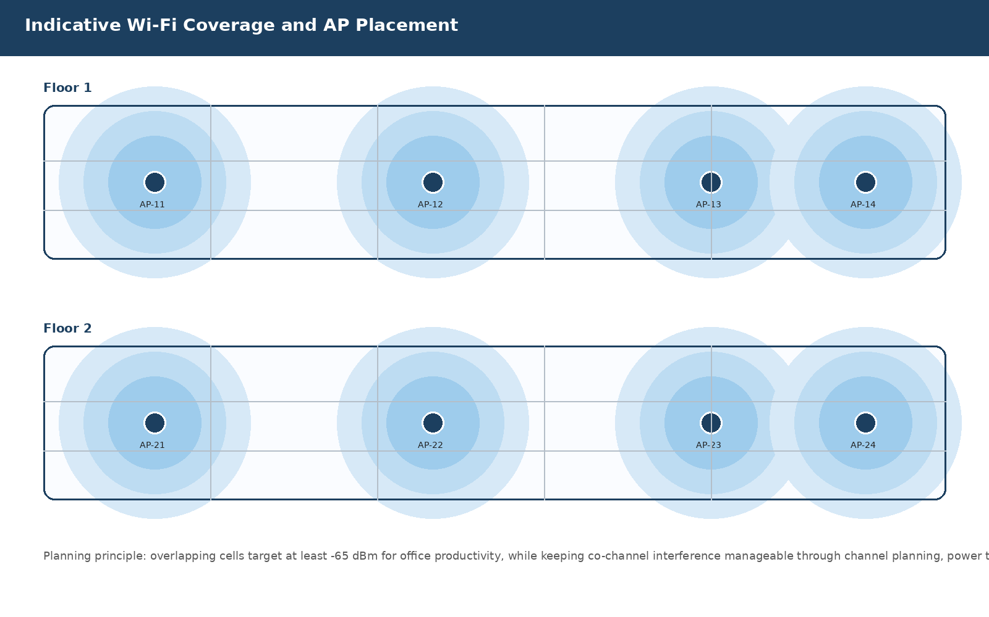
Figure 2. Indicative access point placement and overlapping coverage zones by floor.

4.1 Wireless SSID strategy
A dedicated corporate SSID should be used for domain-joined Windows laptops. This SSID should authenticate through RADIUS backed by Windows Server NPS and Active Directory so that access remains tied to central identity and policy. That is preferable to a shared password model because shared passwords are hard to rotate, hard to audit, and easy to leak.
A separate guest or BYOD SSID should exist for visitors and unmanaged devices. It should terminate into its own VLAN with internet-only access. This separation is important because unmanaged personal devices do not belong on the same trust boundary as corporate laptops, servers, printers, or storage.
Where mobile phones or tablets require internal application access, that requirement should be explicitly defined and handled through a separate policy rather than quietly allowing broad east-west access across the office.

5. Network segmentation, addressing, and policy control
A flat network is rarely the right answer once a business grows beyond a handful of devices. Segmenting the network into VLANs reduces broadcast noise, narrows the blast radius of faults, and gives the business a place to enforce security policy in a controlled way. It also makes troubleshooting easier because user, printer, server, management, and backup traffic stop blending into one large shared segment.
The VLAN design below uses a dedicated server network, separate wired user VLANs per floor, a corporate wireless VLAN, a printer/shared-device VLAN, a guest VLAN, a management VLAN, and a storage/backup VLAN. This is intentionally conservative. The purpose is not to complicate the design but to keep unlike workloads separated so that permissions and firewall policy remain understandable over time.
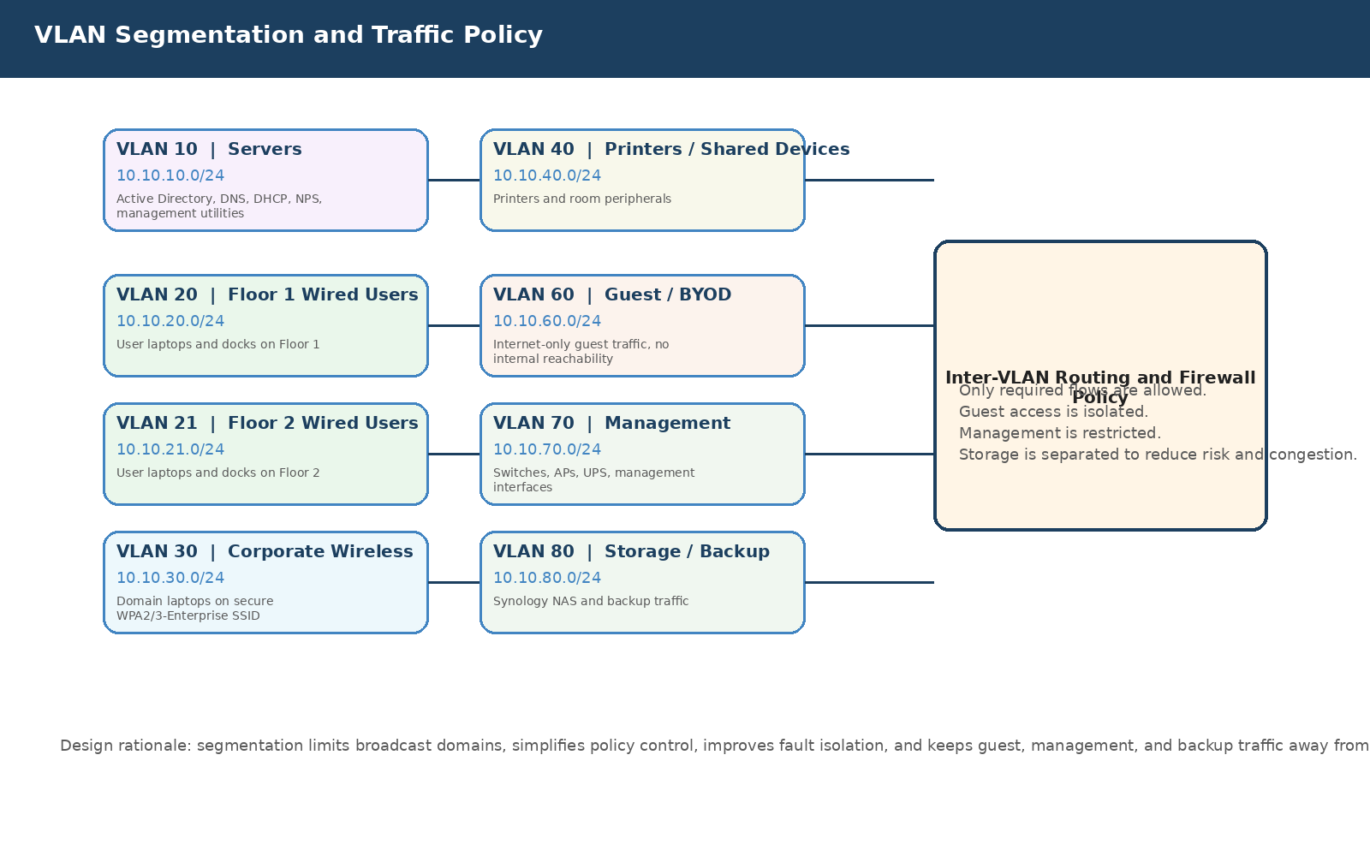
Figure 3. VLAN segmentation model and the role of the firewall in controlling permitted flows.

5.1 VLAN and IP addressing plan
VLAN | Purpose | Subnet | DHCP / static pattern | Why it is separate
10 | Servers | 10.10.10.0/24 | Mostly static | Central services must stay predictable and easy to secure
20 | Floor 1 wired users | 10.10.20.0/24 | DHCP .50-.220 | Keeps floor-level troubleshooting and capacity planning simple
21 | Floor 2 wired users | 10.10.21.0/24 | DHCP .50-.220 | Provides the same clarity for the second floor
30 | Corporate Wi‑Fi | 10.10.30.0/24 | DHCP .50-.220 | Separates roaming user devices from fixed desks and docks
40 | Printers / shared devices | 10.10.40.0/24 | Static or reserved | Shared devices often need tighter access control
60 | Guest / BYOD | 10.10.60.0/24 | DHCP only | Guest devices must not inherit internal trust
70 | Management | 10.10.70.0/24 | Static or reserved | Protects switch, AP, UPS, and management interfaces
80 | Storage / backup | 10.10.80.0/24 | Static | Separates backup and storage flows from user traffic

6. Firewall design and traffic policy rationale
The firewall should operate on a default-deny principle for inter-VLAN access, with explicit allow rules only for business-required flows. This is preferable to broad permit-any policies because permissive rule sets age badly: they accumulate exceptions, become hard to audit, and eventually hide risk in plain sight.
Users should be allowed standard internet access, DNS and Active Directory access to the relevant servers, printing as required, and approved application traffic. Guest traffic should be denied to all internal subnets. Management traffic should be restricted to authorised IT admin devices and accounts. Storage traffic should be limited to approved server and backup paths. These controls are not excessive for a small business; they are the baseline that prevents routine convenience from turning into unnecessary exposure.
Logging should be enabled for both security events and useful operational events. The reason is practical: when users report that something does not work, firewall visibility often distinguishes between a true application issue, a network path issue, and a policy issue in minutes instead of hours.

6.1 Example rule framework
Source | Destination | Ports | Action | Reason
User VLANs | Internet | 80/443 | Allow | Normal business web access
User VLANs | Server VLAN | 53, 88, 389, 445, 636, 123 | Allow | DNS, Kerberos, LDAP, SMB, time sync for domain operation
Corporate Wi‑Fi | Server VLAN | As above | Allow | Domain laptops require the same identity services while roaming
Guest VLAN | Any internal VLAN | Any | Deny | Maintains strict guest isolation
Management VLAN | Network devices | 22, 443, vendor mgmt | Allow | Administrative access only from trusted management segment
Server VLAN | Storage VLAN | SMB / backup traffic | Allow | Server backups and managed file access
Any | Any | Any | Deny | Catches traffic not explicitly justified

7. Windows Server design and authentication services
Windows Server remains the right fit for this environment because the endpoint estate is entirely Windows-based and the business needs straightforward, centralised identity and policy. Active Directory Domain Services, DNS, DHCP, Group Policy, and Network Policy Server all work naturally together and provide a stable operational model for joined Windows laptops.
At least two domain controllers should be deployed. The reason is not merely redundancy on paper. Domain controllers also provide DNS and often DHCP or NPS functions; if one fails, users should still be able to sign in, resolve names, and authenticate to services. Two domain controllers reduce the chance that a single hardware or patching issue becomes an office-wide outage.
A virtualised design using two physical Windows Server hosts running Hyper‑V is strongly preferred over a single host. This gives the business separation between physical failure domains and allows infrastructure VMs to be maintained more cleanly. Even in a small office, this is worthwhile because identity, DHCP, DNS, and line-of-business utilities become easier to manage and recover.

7.1 Core Windows roles
Active Directory Domain Services: Provides central user and computer authentication, security groups, and the organisational structure required for policy.
DNS: Required for reliable internal name resolution and tightly integrated with Active Directory.
DHCP: Provides manageable and auditable address allocation per VLAN rather than relying on ad hoc local DHCP services.
Group Policy: Enforces security baselines, drive mappings, printer deployment, update settings, and desktop standards.
Network Policy Server: Allows enterprise wireless authentication through RADIUS instead of a shared Wi‑Fi passphrase.

7.2 Why Group Policy matters here
Group Policy is often undervalued because users only notice it when it is misconfigured. In a business of this size it is one of the main tools that keeps Windows laptops consistent. It is the mechanism that turns policy into actual device behaviour: BitLocker requirements, screen lock settings, Windows Update timing, mapped drives, printer assignments, and security baselines all become centrally controlled instead of manually curated laptop by laptop.
That consistency lowers support effort. It also helps the business during staff turnover, laptop replacement, and incident response because device configuration remains predictable.

8. Synology storage design and why NAS is separated from identity services
The Synology NAS should act as the primary file storage and backup repository, joined to Active Directory so that access rights are based on domain security groups rather than local NAS accounts. This design is chosen because it gives the business a manageable storage platform without forcing file services onto the domain controllers themselves.
A dedicated storage platform is useful for both performance and risk separation. It keeps file growth and backup retention independent from the Windows Server operating system disks, and it allows snapshots, storage monitoring, and recovery features to operate in a purpose-built environment.
RAID 6 or dual-disk fault tolerance is recommended instead of RAID 5. The reason is simple: modern disk capacities make rebuild risk and rebuild time more significant than they once were. Dual-disk resilience is more suitable for business storage where recovery time and data protection are important.

8.1 Suggested share model and permissions rationale
Share / folder | Primary AD group | Access level | Reason for this structure
Company | GG_AllStaff_Read | Read | Useful for broadly shared policies, templates, forms, and controlled common documents
Departments\Finance | GG_Finance_RW | Modify / Full | Sensitive departmental data should be granted only to the function that owns it
Departments\HR | GG_HR_RW | Modify / Full | HR data requires tighter confidentiality and access tracing
Projects | GG_ProjectTeams_RW | Modify | Project spaces change often and are best tied to managed groups
Management | GG_Leadership_RW | Modify / Full | Restricts higher-sensitivity business information to named leadership groups
Archive | GG_Archive_Read | Read | Allows controlled long-term retention without making archive folders writable by everyone

8.2 Backup and snapshot design
Snapshots should be enabled on critical shares because they provide a fast recovery point against accidental deletion, overwrite, or some ransomware scenarios. They are not a substitute for backup, but they are an excellent first line of operational recovery.
Backups should follow a 3-2-1 logic: multiple copies, at least two media or platforms, and at least one copy offsite or otherwise isolated. The reason is that storage faults, operator error, and security incidents are not the same problem and should not rely on the same recovery path.

9. Physical environment, rack layout, and supportability
The physical layout of infrastructure affects supportability more than many office designs acknowledge. A tidy, labelled, UPS-protected rack is not cosmetic; it reduces recovery time during faults, lowers the chance of accidental disconnection, and improves the reliability of future maintenance.
The rack layout below places heavy UPS equipment low in the cabinet, keeps switching and patching accessible, and groups servers and storage together to simplify power and cabling. This arrangement is recommended because it is easier to cool, easier to document, and easier to work on safely.
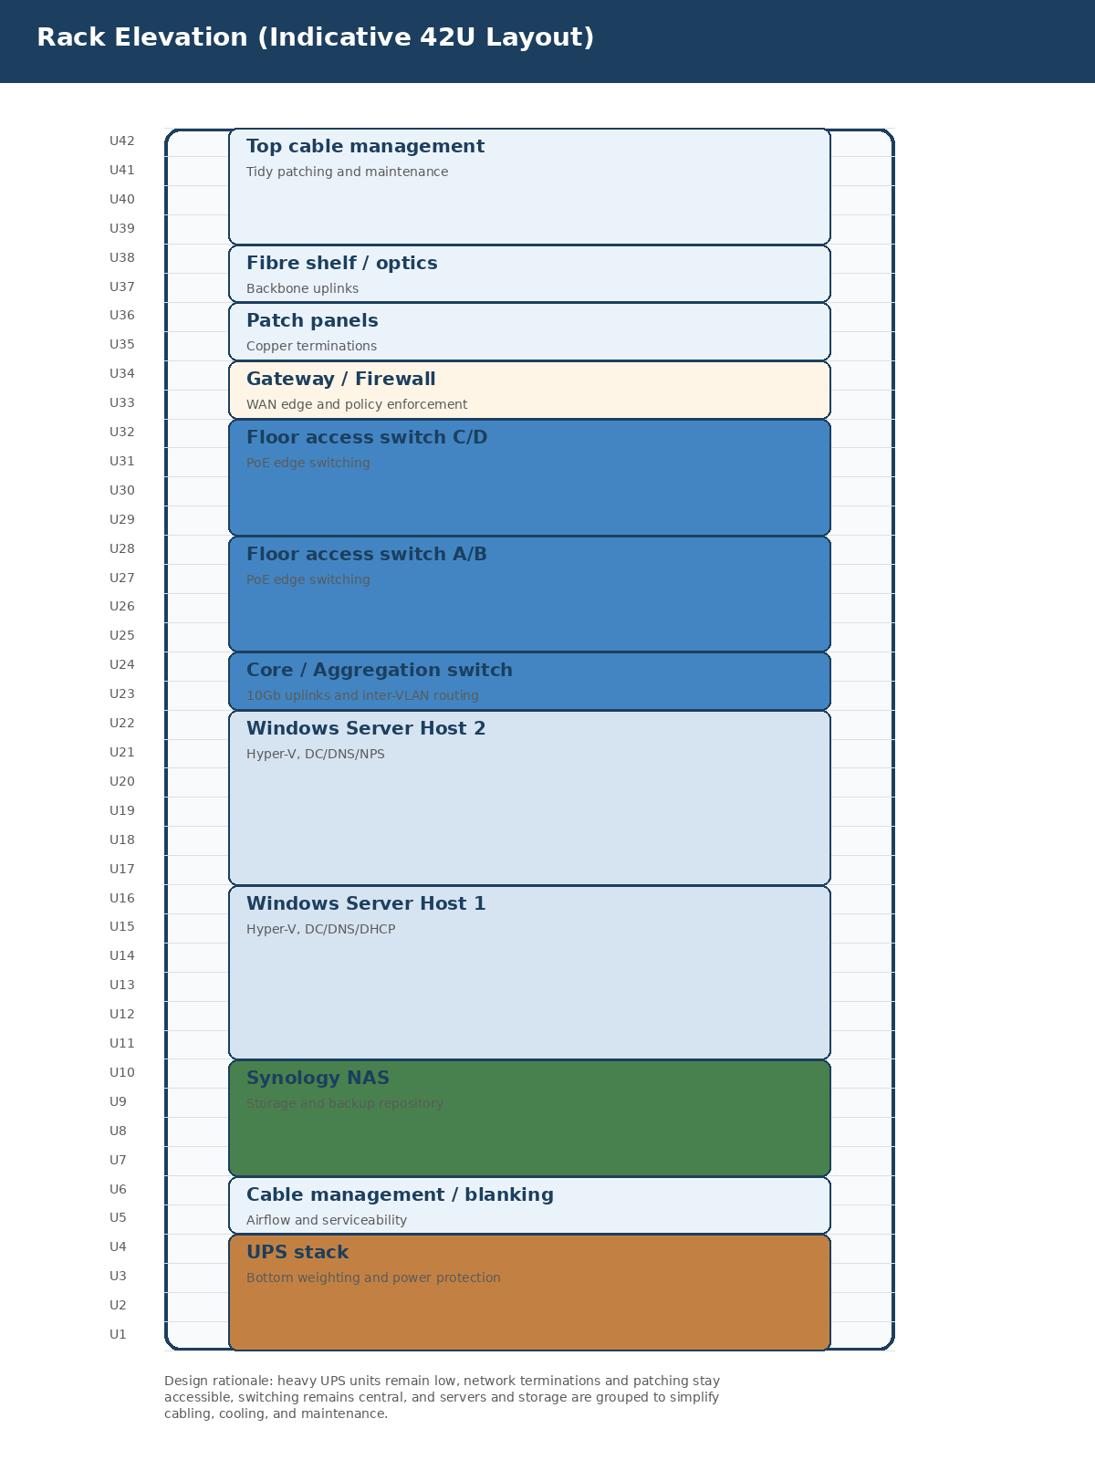
Figure 4. Indicative 42U rack elevation arranged for stability, airflow, and maintainability.

10. Security principles and compliance-minded design choices
This specification deliberately aligns with practical security principles rather than treating security as a separate overlay. Segmentation, central authentication, managed wireless, device encryption, role-based permissions, snapshots, backups, and restricted management access are all design choices that serve day-to-day operations and reduce risk at the same time.
For Windows laptops, BitLocker should be enabled so that device theft does not immediately become data loss. Administrative accounts should be separated from standard user accounts. Local admin rights should be tightly controlled. These measures are valuable because most security failures in smaller environments are not exotic; they usually come from over-broad trust, weak endpoint control, or unmanaged exceptions.
From a standards perspective, the design supports the intent of common control areas such as access control, operational security, asset management, and network security. It is not claimed to be a certification package by itself, but it is a sensible technical baseline that makes later compliance work much easier.

11. Implementation approach and reasons for phased delivery
A phased implementation is strongly recommended. First, confirm cabling, cabinet space, power, and backbone paths. Second, build and validate the switching, VLANs, and wireless. Third, deploy the Windows Server roles and storage services. Finally, migrate users and shared data in a controlled manner. This sequence reduces project risk because it prevents multiple unknowns from changing at once.
Testing should include wired authentication, wireless authentication, printer access, file access, failover behaviour, backup job confirmation, and administrative access validation. The reason to formalise these checks is that handover quality is usually determined by what was tested, not by what was installed.

12. Recommended bill of materials at a planning level
The following bill of materials is expressed at planning level rather than as a locked purchase order. Exact model choice should be confirmed against current supplier availability, desired support posture, cabinet constraints, and PoE budgets. The important point is to preserve the architecture: a managed firewall at the edge, 10Gb-capable aggregation, enough PoE access ports, business Wi‑Fi density, two Windows Server hosts, and resilient Synology storage.
Component | Qty | Indicative class | Reason
UniFi gateway / firewall | 1 | Business edge appliance | Central security, segmentation, VPN, and WAN policy
10Gb aggregation / core switch | 1 | Managed aggregation switch | Backbone for floors, servers, and storage
Managed PoE access switches | 4 | 48-port class | User connectivity plus AP and shared-device power
Wi‑Fi 6 access points | 8 | Enterprise AP class | Coverage and capacity across both floors
Windows Server hosts | 2 | Business rack servers | Resilient virtualised identity and infrastructure services
Synology NAS | 1 | 8-bay or larger | Central file storage, snapshots, and backup target
UPS systems | 2+ | Rack UPS | Power conditioning and graceful shutdown capability

13. Conclusion
This design is intentionally practical. It avoids the false economy of under-specifying the network backbone, using consumer wireless, or blending servers, printers, guests, and users into one shared segment. Those choices can reduce purchase cost on day one but usually increase support cost, performance complaints, and security exposure over time.
By using managed wired and wireless infrastructure, Windows-based identity, and Synology-based storage with snapshots and backup separation, the business gains a network that is understandable, supportable, and ready for moderate growth. The diagrams and explanations in this document are intended to help procurement, technical teams, and management arrive at the same understanding of why each design decision exists.

